**Misr International University** 

**Course Code & Title: SWE230 Web Development**

**Semester: Spring 2022 Instructor: Dr. Mohamed ElGazzar**

**Lab manual 5**

**JavaScript**

Scripts can be added using the <script> tags in the html either in the body or the head. Or they could be added in a separate file and later on be linked in html file.

* **Scripts in head:**

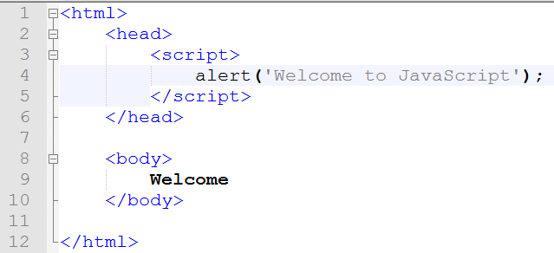

* **Scripts in body:**

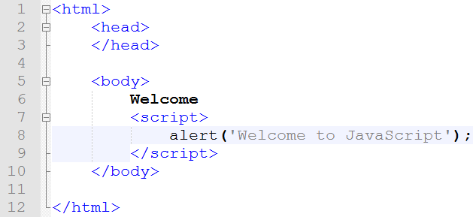

* **Linking external scripts:**





**Variables in JS:**

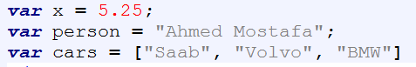

**Var, let:**

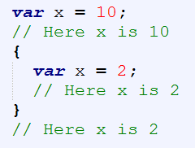 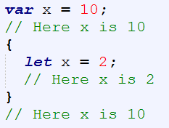

**Using Functions**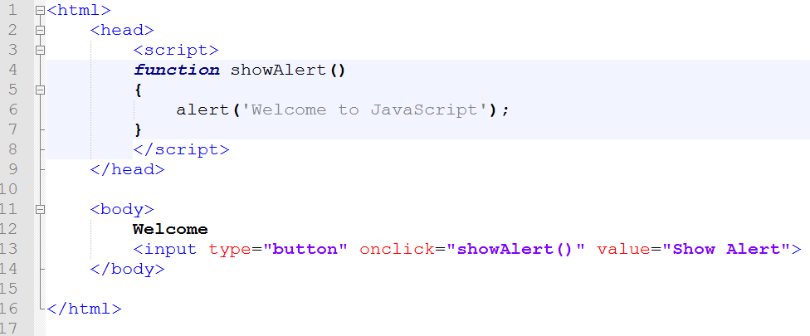

**Changing HTML attributes**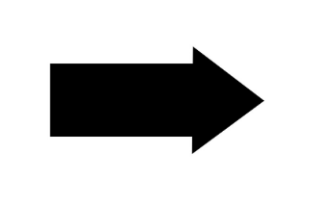

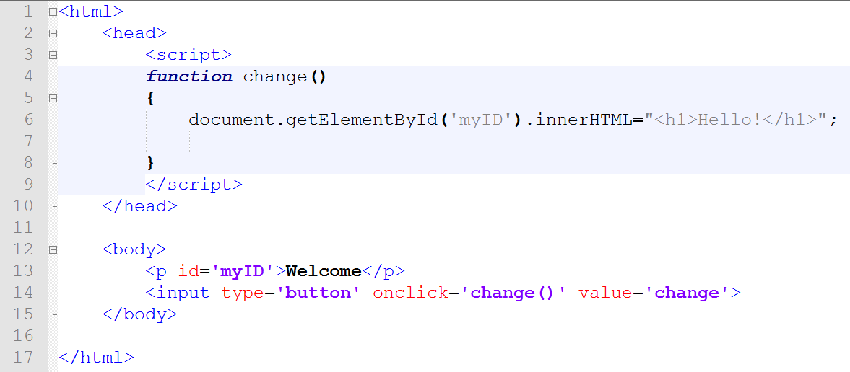

**Output:**

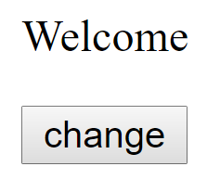 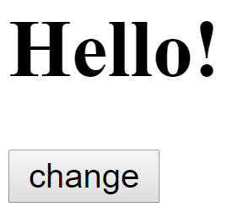

**Input Validation**

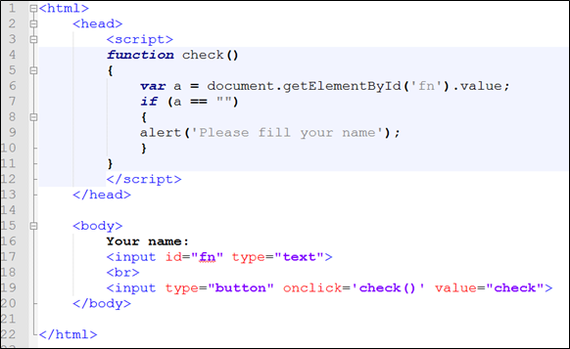

**Output:**



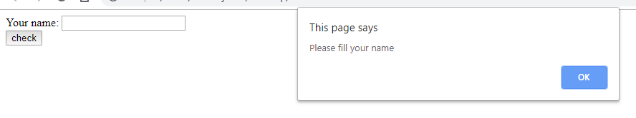

## PHP filter_var() Function

The filter_var() function both validates and sanitizes data.

The filter_var() function filters a single variable with a specified filter. It takes two pieces of data:

* The variable you want to check
* The type of check to use

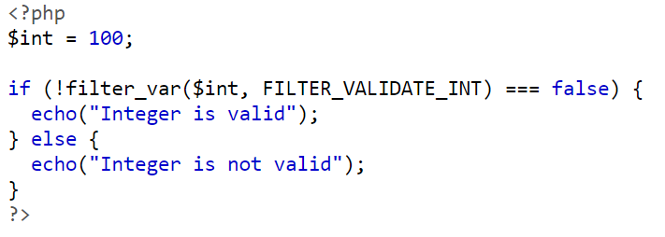

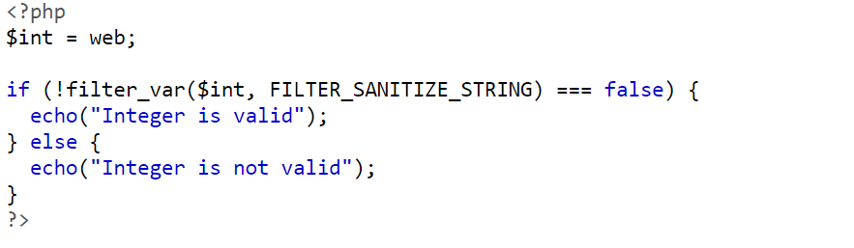

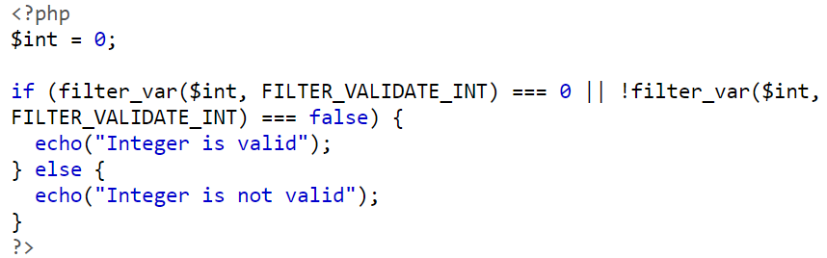

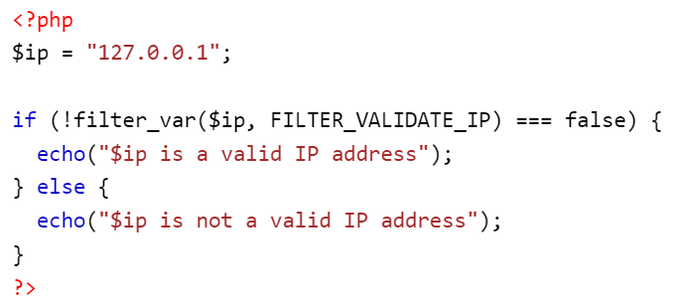

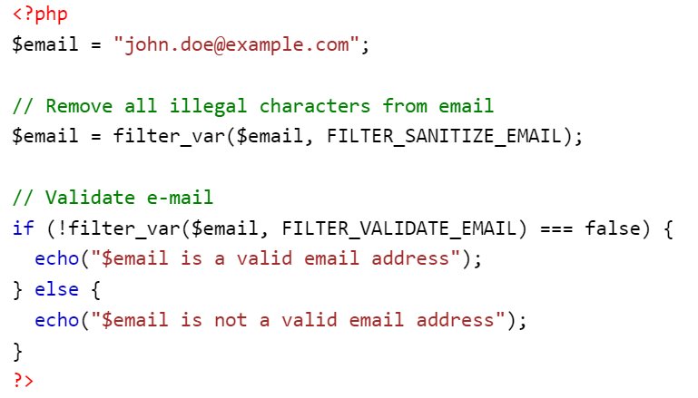

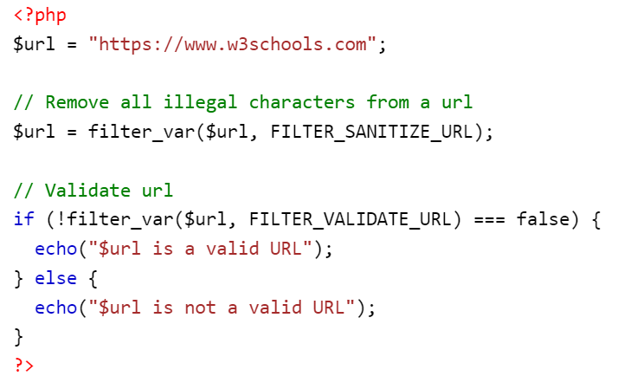

**Exercise**

**1.change image by using javascript**

**In this example JavaScript changes the value of the src (source) attribute of an <img> tag**

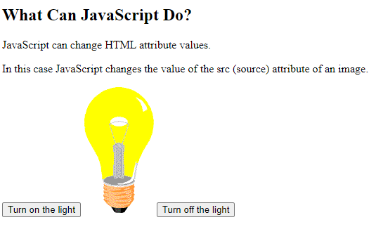

**2.website:**

The “UserName” and “Password” should be inserted into the database when the user clicks on “submit”and validates input using javascript.

Validate all forms in

* Signup
* Login
* EditInfo